|  |  |
| --- | --- |
| Date | 07 NOV 2022 |
| Team ID | PNT2022TMID47367 |
| Project Name | Customer Care Registry |

TECHNOLOGY ARCHITECTURE

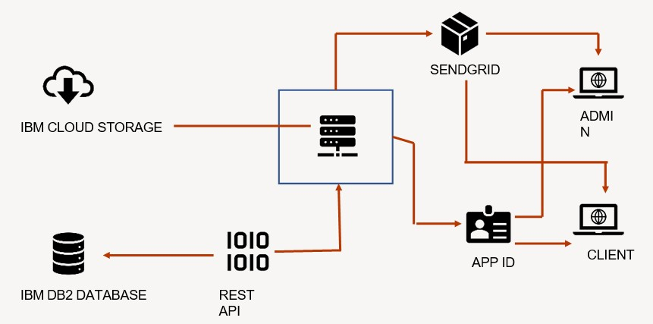

|  |  |  |  |
| --- | --- | --- | --- |
| **S.NO** | **COMPONENT** | **DESCRIPTION** | **TECHNOLOGY** |
| 1. | UserInterface | How user interacts with application e.g.WebUI, MobileApp, Chatbot etc. | HTML,CSS,JavaScript/Angular  Js/ReactJs etc. |
| 2. | Application Logic-1 | Logic for a process in the application | Python |
| 3. | Application Logic-2 | Logic for a process in the application | IBM Watson STT service |
| 4. | Application Logic-3 | Logic for a process in the application | IBM Watson Assistant |
| 5. | Database | DataType,Configurations etc. | MySQL etc |
| 6. | Cloud Database | DatabaseServiceon Cloud | IBM DB2,IBMCloudant etc. |
| 7. | File Storage | File storage requirements | IBM Block Storage or Other  Storage Service or Local Filesystem |
| 8. | Infrastructure (Server/Cloud) | Application Deploymenton Local System/Cloud Local Server Configuration:CloudServer Configuration: | Local,CloudFoundry,Kube rnetes,etc. |

APPLICATION CHARACTERISTICS

|  |  |  |  |
| --- | --- | --- | --- |
| **S.No** | **Characteristics** | **Description** | **Technology** |
| 1. | Open-Source Frameworks | List the open-source frameworks used | Python flask |
| 2. | Security Implementations | List all the security/access control simple mented,use of firewalls etc. | s |
| 3. | Scalable Architecture | Justify the scalability of architecture(3– tier,Micro-services) | Supports higher workloads without any fundamental changes to it. |
| 4. | Availability | Justify the availability of application (e.g.use of load balancers,distributed serversetc.) | High availability enables your IT infrastructure to continue functioning even when some of its  components fail. |
| 5. | Performance | Design consideration for the performance of the application(number of requests per sec,use of Cache,use of CDN’s) etc. | Performance technology, therefore, is a field of practice that uses various tools,processes,and ideas in a scientific, systematic manner to improve the desired outcomes of  individuals and organizations. |